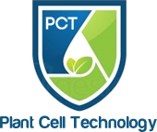

CERTIFICATE OF ANALYSIS
PLANT PRESERVATIVE MIXTURE
PPMTH

Produced in District of Columbia State, United States of America, September 2021
Bottled in District of Columbia State, United States of America, September 2021

Batch Number: 2145
Expiration Date: April 2023

NJ EPA Establishment No. 90849-NJ-001
DC EPA Establishment No. 70816-DC-001
EPA Product Registration No. 70816-1

Analysis Results

5-Chloro-2-methyl-3(2H)-isothiazolone .……….. 0.1350%
2-methyl-3(2H)-isothiazolone …………………..... 0.0412%

Inert Ingredients (H20) ………………………………….…. 99.82338%

Yoni Kalin

